D365 Analytics Assets

PowerBI for Dynamics 365 Sales and Service Demos

# Section One: Adding the PowerBI Assets to your Demo Environment

## Pre-Requisites to installation

1. PowerBI Pro licenses assigned to your demo users.
2. In your environment, ensure that “PowerBI Visual embedding” is enabled.   
   [In the “Settings > Administration > System Settings > Reporting” tab]
3. Install the version of PowerBI **desktop** from the windows store: <https://aka.ms/pbidesktop>  
   (If you have installed it as a download from the PowerBI page in the past, uninstall that version and use the one from the store. – The version from the store will remain updated automatically as new releases are available.)
4. Ensure that you are logged in to PowerBI desktop with your TS account (or as an Admin in the demo instance you’re collaborating in.)  
   A screenshot of a social media post

   Description automatically generated
5. In PowerBI, under the ‘File’ menu, choose ‘Options and Settings’ and enable a couple of features that are still in preview as of Feb 2020 – The **Updated Ribbon** and **Decomposition Tree.**A screenshot of a cell phone

   Description automatically generatedA screenshot of a cell phone

   Description automatically generated

## Create Copies of the files (and Rename them)

1. Copy the PowerBI Reports and the Excel File to your prospect or environment folder.  
   I suggest you create a separate folder for these files *per environment* – (or even per prospect if you want to keep archives of your work as you go.)
2. Once moved, *Rename the files* to include the prospect or demo environment name. (This keeps this collection of files from overwriting or interfering with other copies of the dashboards once they are loaded into your Power BI instance.)

## Editing the Source Data

1. Open the Excel file and click ‘save’ to refresh it. (due to the size ‘auto-recalculate’ is turned off – but whenever you ‘save’ the file, it will recalculate the dates and values before the save is complete.)

We’ll look at how to more at how to play around with this file later – but for now – try changing the expected number of opportunities or cases per day, then click save. – you’ll see the times between Cases or Opportunities increase or decrease. – Note that there are only 13 users in the sample data, so these records are roughly divided among those users.

Also – you can update the product names and LOBs – along with expected minimum or maximums of the different products. – Note that there are 10 products – you can change the *Products, LOBs, MinOppValue/MaxOppValue, and a Success weighting factor,* of the products to whatever aligns with the customer’s use-case – but for this demo data adding/removing more or fewer product line items is not supported.

1. Press **[F9]** to recalculate the worksheets, then Save and close the Excel file. (Later on, you’ll need to ensure that the Excel file isn’t open in Excel whenever you ‘refresh’ within PowerBI – the file lock on the local file will prevent Excel and PowerBI from playing nicely with each other.)

## Connect the PowerBI file’s Data Source to your Excel file

1. Open the Dynamics Analytics Power BI file – and open **Data Source Settings**

1. Update PowerBI with the new name and location of the Excel file.  
   (The Excel file must be closed before you can select it as a data source in PowerBI.)A screenshot of a cell phone

   Description automatically generated
2. After changing to a new source file, it will prompt you to “Apply changes” to refresh the data in the reports. After this, just click ‘Refresh’ in the ribbon to update PowerBI with the updated data in the excel file. (Ensure that the Excel file isn’t open in Excel whenever you ‘refresh’ – the file lock on the local file will prevent Excel and PowerBI from playing nicely with each other.)  
   A screenshot of a social media post

   Description automatically generated  
   (Whenever you’ve updated the Excel file, just click [F9] to refresh the Excel formulas, then close the file and then in Power BI click the ‘Refresh’ button to see the changes in Excel updated into Power BI.)

## Publish the file to PowerBI

1. Now we’ll publish the Report to your TS Power BI instance. (ensure you’re logged in to PowerBI with your TS account – or Dynamics 365 CE admin account.)  
     
   Save the file and then Click “Publish”  
   A screenshot of a computer screen

   Description automatically generated  
     
   Save this to your “My Workspace” area. (Saving to other workgroups is also supported, but for purposes of this set of instructions, we’ll stick with ‘My Workspace’ to reduce confusion.)  
   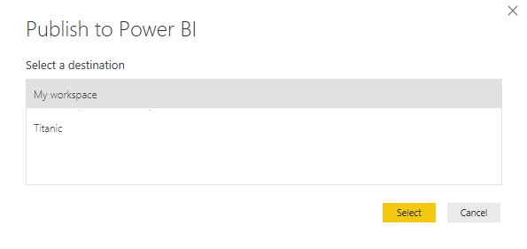
2. Open <https://app.powerbi.com/groups/me/list/reports>, you should have a copy of the report. – (Be sure you’re logged into PowerBI using the same credentials you used to publish the report.)  
   A screenshot of a social media post

   Description automatically generated
3. Open the report and begin ‘pinning’ visuals from your report onto a dashboard that you’ll surface in Dynamics.  
   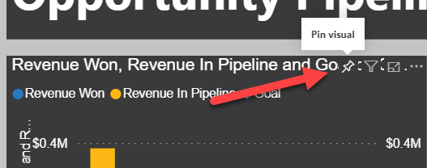  
     
   Here are some examples – but you can shape and arrange whatever best tells the customer story.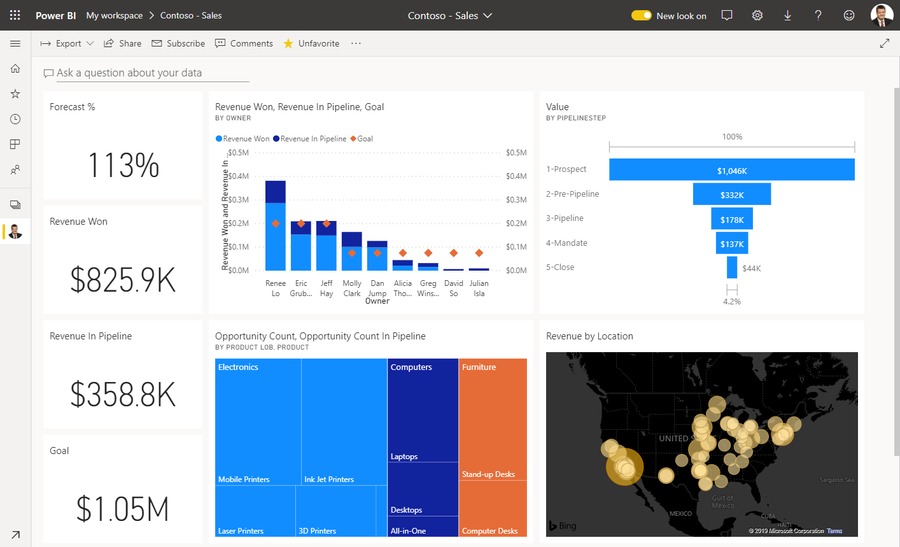   
   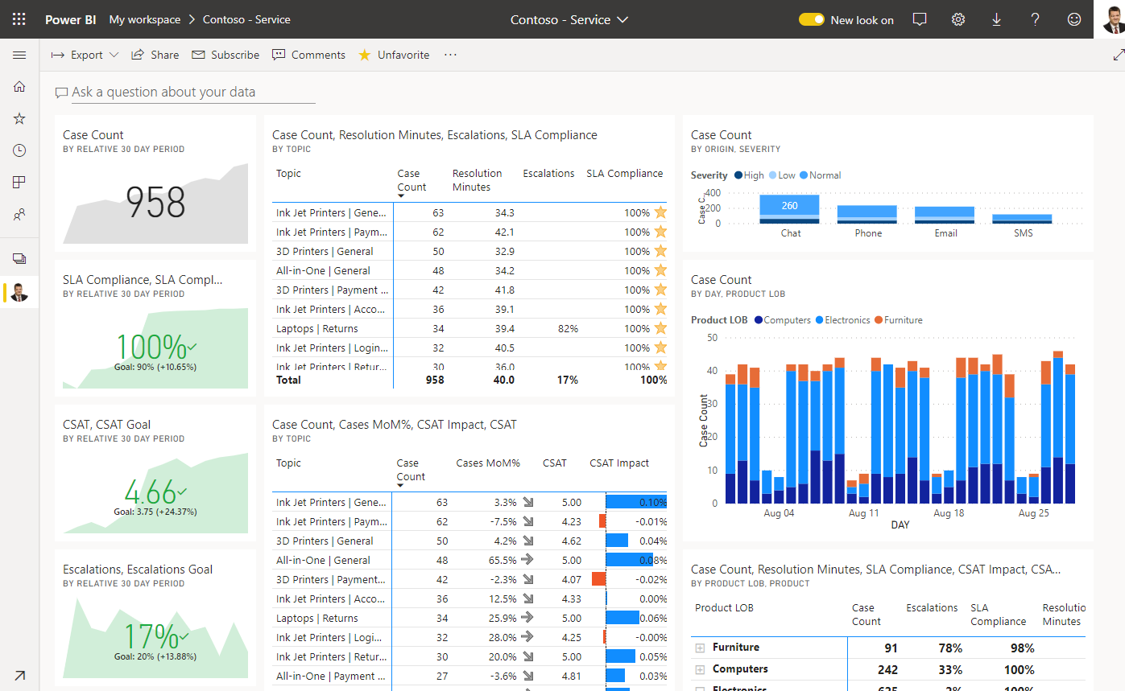

These dashboards can now be added to Dynamics.

# Section Two: Adding a PowerBI report to the account form (Advanced)

A contextual report on an entity form gives the user a powerful tool to show a rollup and metrics around the interactions with a specific account, as an example. A report can be added to an entity form and that report is automatically filtered to the current record.

The “*XXX - Dynamics Analytics - Account Drill Down.pbix*” report is already configured to use the same dataset published with the main report. There are only a few steps needed to update and publish it into your environment.

## Update the Sample data with the account names and GUIDs from your organization.

Update the account tab in the Excel file to include the Names & GUIDs of your accounts.

1. Export the list of your accounts as a static list.  
   A screenshot of a computer

   Description automatically generated
2. Open it in Excel and ‘Unhide’ Columns A, B, and C (They’re hidden by default in an export.)  
   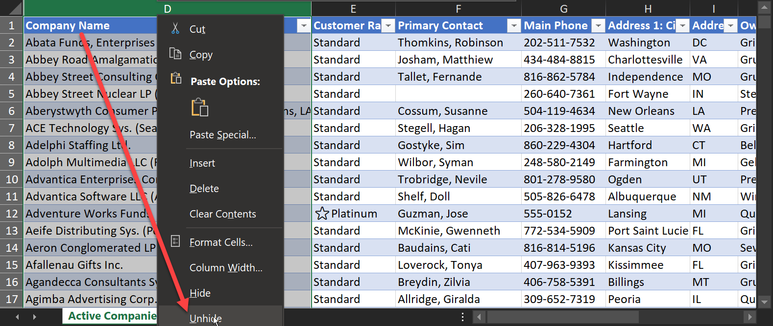  
   (Column “A” should be the Account ID)
3. Add the AccountIDs and the Names of your accounts (and the addresses, etc. if desired) to the corresponding columns on the ‘Account’ Tab of the Data source Excel File. (This step is necessary since the embedded report will be filtered based on the AccountId of the current account record.  
     
   A screenshot of a computer screen

   Description automatically generated  
     
   Hit refresh (F9) to update the excel file then Save and close the PowerBI Source Data Excel file.

## Publish the drill-down report to Dynamics

1. Re-Publish the primary (XXX - Dynamics Analytics.pbix) report file to ensure the updated date is in the PowerBI service.  
   A screenshot of a computer

   Description automatically generated
2. Open the Drilldown report (XXX - Dynamics Analytics - Account Drill Down.pbix)   
   If this is the first time you’re uploading a new copy of this report, you should get an error message indicating it can’t find the dataset.  
   A screenshot of a cell phone

   Description automatically generated

Just click “Edit” and repoint the data source to the primary report’s dataset in the PowerBI service.  
  
Once the report opens, it should point to the correct dataset. – you can check it at the bottom of the report window.

If the ‘drill-down’ report isn’t pointing to the correct dataset, click “Data source setting” (under the “Transform data” menu) to re-point to the correct dataset.

1. Publish the drill-down report to the same workspace as the primary report.

## Create a Report Placeholder on your form

1. In Dynamics Configuration, add a new, blank tab to the Account form(s) you are using in your demo environment.
   1. In the admin area (make.powerapps.com) navigate to the forms on the Account entity  
      A screenshot of a cell phone

      Description automatically generated
   2. Create a report place holder.   
      Add a new 1-Column Tab to the form. Change the name to “tab_Analytics” and add a user-friendly label such as “Account Analytics” – then Save and Publish the change.  
      A screenshot of a cell phone

      Description automatically generated
2. Use the XRM Toolbox (<https://www.xrmtoolbox.com/>) utility ”Power BI Embedder” to add the report to the account form .
   1. Connect XRMToolBox to the environment
   2. Search for and open the “Power BI Embedder” plugin.   
      A screenshot of a cell phone

      Description automatically generated(More information about this utility is located here: <https://dynamicsninja.blog/2019/12/05/power-bi-embedder-for-xrmtoolbox/>)
   3. Select the Account entity in the first drop-down.
   4. In the next three dropdowns, select the Form, Tab, and Section from the earlier steps where you configured the report placeholder.   
      A screenshot of a social media post

      Description automatically generated
   5. Change the “Rowspan” value to 15
   6. Set the filter checkmark to yes.
   7. In the filter area on the lower right-hand corner, use “Accounts” as the table and “AccountID” as the PBI Column. (CaSe SeNsiTivE!)   
      Select “accountid” from the CDS Field dropdown.
   8. Leave the ‘Group ID’ with all zeros and the URL will likely remain the default.
   9. For the report ID – you’ll find that in the URL of the report like this:A screenshot of a computer screen

      Description automatically generated
3. Save and publish the report from within the PowerBI Utility.  
   A screenshot of a social media post

   Description automatically generated

## Finally view the contextually filtered report in Dynamics

1. Open one of your account records in Dynamics and switch to the new Analytics tab.  
   The embedded report should be filtered to the record you have open. (of course, the count of opportunities, calls, cases and everything else is sourced from the Excel file, so don’t be surprised by that.)  
   A screenshot of a cell phone

   Description automatically generated